Equality Impact Assessment (EqIA)

You will need to produce an Equality Impact Assessment (EqIA) if:

- You are developing a new policy, strategy, or service
- You are making changes that will affect front-line services
- You are reducing budgets, which may affect front-line services
- You are changing the way services are funded and this may impact the quality of the service and who can access it
- You are making a decision that could have a different impact on different groups of people
- You are making staff redundant or changing their roles

Guidance notes on how to complete an EqIA and sign off process are available on the Hub under Equality and Diversity.
You must read the guidance notes and ensure you have followed all stages of the EqIA approval process (outlined in appendix 1).
Section 2 of the template requires you to undertake an assessment of the impact of your proposals on groups with protected characteristics. Equalities and borough profile data, as well as other sources of statistical information can be found on the Harrow hub, within the section entitled: Equality Impact Assessment - sources of statistical information.

Equality Impact Assessment (EqIA)

Type of Decision:
Title of Proposal | Investment into Harrow’s Tennis Infrastructure | Date EqIA created 12/04/22
Name and job title of completing/lead Officer | Tim Bryan – Head of Service, Culture and Leisure
Directorate/ Service responsible | Place/Inclusive Economy, Leisure and Culture
Organisational approval
EqIA approved by Equality, Diversity and Inclusion Team | Name: Micah McLean  Policy Officer – equality, Diversity and Inclusion Team | Signature mmclean  ☒  Tick this box to indicate that you have approved this EqIA  Date of approval 06/05/2022

- Summary of proposal, impact on groups with protected characteristics and mitigating actions
(to be completed after you have completed sections 2 - 5)
a) What is your proposal? To enter into a funding agreement with the Lawn Tennis Association (LTA) if the Council’s application to the LTA’s Renovation Fund is successful for capital funding to improve tennis facilities at a number of Harrow’s parks that are currently in a poor condition to increase use of the courts and improve levels of physical activity in Harrow. This will include the resurfacing of the courts, repairs to fences, as well as the introduction of gate access technology and an online booking system. A pay and play system would be in operation with the introduction of charging for members of the public to hire the courts per hour. There would, however, be a free weekly tennis session at some of the courts. This would be in accordance with the LTA’s criteria for usage that there is a free weekly tennis session at a minimum of 30% of the parks involved to address income inequality and maximise take up. The income generated will be reinvested into maintaining the courts to a high standard ensuring that the courts are sustainable going forwards. It is proposed that the courts would be operated by a tennis operator who will also deliver coaching sessions to help increase the number of people playing tennis and to enable players to develop their skills.
b) Summarise the impact of your proposal on groups with protected characteristics
No protected characteristic would be adversely affected by these proposals. Renovating the tennis courts to a playable standard and introducing a pricing strategy for usage that will ensure the courts can be maintained in the future will improve access to tennis for the whole community. There will still be some free weekly session at some of the courts to ensure that there is a maximisation of usage and to address income inequality. A tennis operator will be procured to manage the refurbished courts and will provide coaching sessions and the opportunity for the public to play competitive tennis if they wish to so. This will have a positive impact for people of all ages, for those with a disability with specific sessions for this target group to be held by the operator, and for all race/ethnic groups. The new access gates will be fully accessible being the required width for wheelchair users and the gate keypad located at a height accessible to all. There would be an online booking system introduced to improve the customer’s journey to hiring a court making the process simpler and easier, but the tennis operators would also be expected to detail how the courts could be booked for those with limited access to a computer or who have limited digital skills.
c) Summarise any potential negative impact(s) identified and mitigating actions
No specific negative impact has been identified for any of the protected characteristics from these proposals as detailed in b) above.

2. Assessing impact
You are required to undertake a detailed analysis of the impact of your proposals on groups with protected characteristics. You should refer to borough profile data, equalities data, service user information, consultation responses and any other relevant data/evidence to help you assess and explain what impact (if any) your proposal(s) will have on each group. Where there are gaps in data, you should state this in the boxes below and what action (if any), you will take to address this in the future. |  | What does the evidence tell you about the impact your proposal may have on groups with protected characteristics? Click the relevant box to indicate whether your proposal will have a positive impact, negative (minor, major), or no impact
Protected characteristic | For each protected characteristic, explain in detail what the evidence is suggesting and the impact of your proposal (if any). Click the appropriate box on the right to indicate the outcome of your analysis. | Positive impact | Negative  impact |  | No impact
 |  |  | Minor | Major
Age | The resident population of Harrow according to the 2020 mid-year population estimates was 252,338. According to the Annual Workforce Equalities Report 2020- 2021 the age demographic of our resident population is as demonstrated below:  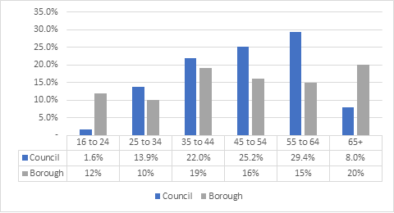  Bringing all the tennis courts up to a playable standard will benefit people of all ages as it will make tennis more accessible and provide opportunities for people of all ages to attend coaching sessions and also to participate in competitive tennis with people of a similar ability if they wish to do so. Whilst the charge rates for the pay and play sessions will be set by the tennis operator, the Council will work with the operator to ensure that the charging rates are affordable for all. There would be an online booking system, but tennis operators would be expected to detail how the courts could be booked for those with limited access to a computer or who have limited digital skills. | ☒ | ☐ | ☐ | ☐
Disability | According to the Annual Workforce Equalities Report 2020- 2021, 15.8% of the borough’s population discloses a disability. This is indicated below:  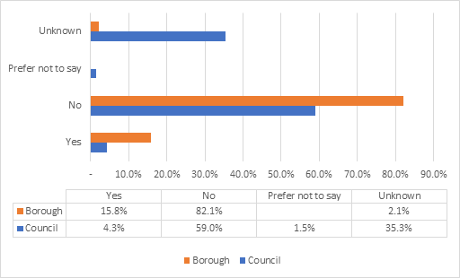  Bringing all the tennis courts up to a playable standard will benefit people with a disability. The specification for the procurement of a tennis operator would include a requirement to ensure that there are sessions aimed at people with disabilities, and there will be some free tennis sessions available at some of the parks to address income inequality.  Whilst the charge rates for the pay and play sessions will be set by the tennis operator, the Council will work with the operator to ensure that the charging rates are affordable for all. New accessible gates will be installed to enable access for everyone. The new gates will be the required width for wheelchair users and the gate keypad will be at a height which is accessible to all. | ☒ | ☐ | ☐ | ☐
Gender  reassignment | The only data Harrow currently has on Gender Reassignment is via the Analysis of demand from housing applicants (via Locata): 1 (0.02%) housing applicant has indicated that they are transgender.(Data as of April 2014).  No specific impact has been identified for this protected characteristic from these proposals | ☐ | ☐ | ☐ | ☒
Marriage and Civil Partnership | Census data: Harrow has a very high percentage of married couples, with 53.7% of residents aged 16 and older declaring they were in a marriage in 2011. This is above the national level of 46.6%. There was a 27% increase in the number of married people living in Harrow between 2001 and 2011 (Office for National Statistics, 2001 and 2011). Between their inception and January 2012, 107 civil partnership ceremonies took place in Harrow.  No specific impact has been identified for this protected characteristic from these proposals | ☐ | ☐ | ☐ | ☒
Pregnancy and Maternity | The 2020 mid-year estimates showed a decrease of 37 births (3,506 births in total) over 2019 mid-year estimates, a 1% decrease. There was a consistent increase from 2001/02 to 2012/13.  No specific impact has been identified for this protected characteristic from these proposals | ☐ | ☐ | ☐ | ☒
Race/  Ethnicity | According to the Annual Workforce Equalities Report 2020- 2021 the race demographic of our resident population is as demonstrated below:  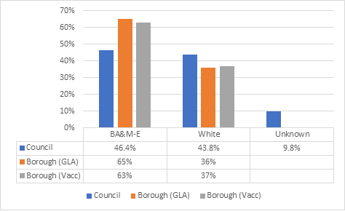  Black, Asian and Multi-Ethnic residents make up around 65% of our borough’s population followed by White groups at 36%. Bringing all the tennis courts up to a playable standard will benefit people from all ethnic groups. There will be some free sessions and concessionary rates targeted towards residents from different ethnicities from disadvantaged socio-economic backgrounds. | ☒ | ☐ | ☐ | ☐
Al economic backgrounds.  Religion or belief | The Annual Workforce Equalities Report mentions that Christianity (37%), Hinduism (28%), No religion/ Atheist (13%) and Islam (12%) are the four biggest religious demographics in Harrow. Residents that are of the Jewish faith is 3% of the borough population.  The graph below illustrates this data in more detail:  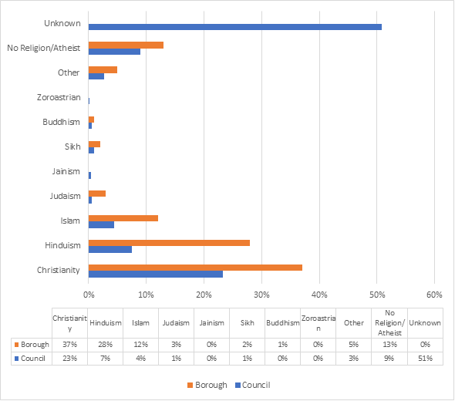  No specific impact has been identified for this protected characteristic from these proposals | ☐ | ☐ | ☐ | ☒
Sex | The Annual Workforce Equalities Report 2020-2021 indicates that the percentage of residents within Harrow that are male and female is split evenly at 50%. As shown below:  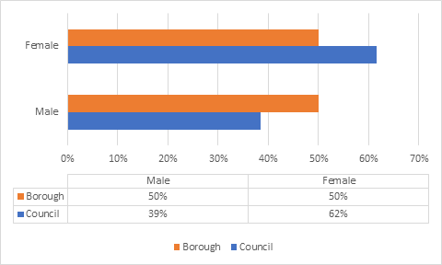  No specific impact has been identified for this protected characteristic from these proposals | ☐ | ☐ | ☐ | ☒
Sexual Orientation | The Annual Workforce Equalities Report 2020-2021 indicates that the percentage of LGBTQIA+ residents within London is 4.5%. See below:  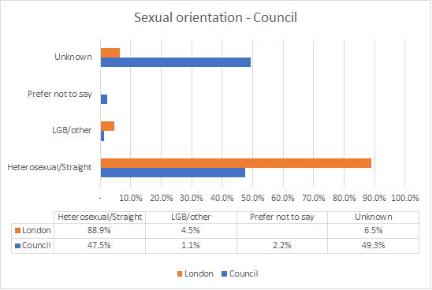  No specific impact has been identified for this protected characteristic from these proposals | ☐ | ☐ | ☐ | ☒
2.1 Cumulative impact – considering what else is happening within the Council and Harrow as a whole, could your proposals have a cumulative impact on groups with protected characteristics?
☐ Yes No ☒

If you clicked the Yes box, which groups with protected characteristics could be affected and what is the potential impact? Include details in the space below

2.2 Any other impact - considering what else is happening nationally/locally (national/local/regional policies, socio-economic factors etc), could your proposals have an impact on individuals/service users, or other groups?
☐ Yes No ☒
If you clicked the Yes box, Include details in the space below

3. Actions to mitigate/remove negative impact
Only complete this section if your assessment (in section 2) suggests that your proposals may have a negative impact on groups with protected characteristics. If you have not identified any negative impacts, please complete sections 4 and 5.

In the table below, please state what these potential negative impact (s) are, mitigating actions and steps taken to ensure that these measures will address and remove any negative impacts identified and by when. Please also state how you will monitor the impact of your proposal once implemented.
State what the negative impact(s) are for each group, identified in section 2. In addition, you should also consider and state potential risks associated with your proposal. | Measures to mitigate negative impact (provide details, including details of and additional consultation undertaken/to be carried out in the future). If you are unable to identify measures to mitigate impact, please state so and provide a brief explanation. | What action (s) will you take to assess whether these measures have addressed and removed any negative impacts identified in your analysis? Please provide details. If you have previously stated that you are unable to identify measures to mitigate impact please state below. | Deadline date | Lead Officer

4. Public Sector Equality Duty
How does your proposal meet the Public Sector Equality Duty (PSED) to:
- Eliminate unlawful discrimination, harassment and victimisation and other conduct prohibited by the Equality Act 2010
- Advance equality of opportunity between people from different groups
3. Foster good relations between people from different groups

Include details in the space below
The proposal to apply for funding to bring the tennis courts up to a playable standard in several of the parks and introduce a pricing strategy with a weekly free session at some of the parks to address income inequality and maximise usage will enable sustainable greater participation in tennis in the borough for all ages and abilities. Coaching sessions will also be introduced and there will also be the opportunity for people to play competitive tennis if they wish to do so. This will help to meet the sport and physical exercise needs of the whole community and bringing different communities together.

5. Outcome of the Equality Impact Assessment (EqIA) click the box that applies
☒ Outcome 1
No change required: the EqIA has not identified any potential for unlawful conduct or disproportionate impact and all opportunities to advance equality of opportunity are being addressed

☐ Outcome 2
Adjustments to remove/mitigate negative impacts identified by the assessment, or to better advance equality, as stated in section 3&4

☐ Outcome 3
This EqIA has identified discrimination and/ or missed opportunities to advance equality and/or foster good relations. However, it is still reasonable to continue with the activity. Outline the reasons for this and the information used to reach this decision in the space below.

Include details here

